Document Control
Document Name | Meeting Rooms App PRD
Version No | 1.0
Classification | Internal
Date | 11/04/2022

Version Control
Ver No. | Author | Approved by | Approved Date | Description
1.0 | Jovil Nazareth | Ujjwal Trivedi | 23rd April 2022 | Build MR app UI, Book Now, Book later, Calendar component
1.1 | Jovil Nazareth | Ujjwal Trivedi | 31st May 2022 | Filter and sort Available rooms

MEETING ROOMS - APP - PRD

Problem Statement:
Across the globe, mobile usage has exploded and there’s an increasing demand for mobile apps. By going mobile first, services are more accessible and easy to use. Modern consumer behavior prioritizes convenience. In extension to our product, organizations (a reflection of the collective users) prefer a single app for all bookings and check-in.

Objective:
To build a mobile application for meeting rooms which helps the user search for available meeting rooms easily, book on the go and check-in into the room.

Figma: https://www.figma.com/file/nxvQv2W2fho62VF9qnQVRY/Meeting-Room?node-id=196%3A45773

Requirement:

Navigating to Meeting rooms (App side):

- The fab button should have an option to “Book Room”. This should have an icon as mentioned below
- The hamburger menu on the app should have an option “Meeting Room”. This option should appear after Preference, but before FAQs
- Design and icon is as below


Showing Available Rooms:

- When the user clicks on the fab button, a page loads which contains available rooms
- Available room is any room that is available for that particular date
- In case the user navigates to a date where the room is disabled, then that room should not be visible in the list of rooms
- Available rooms should be visible upfront. Sorting of this is explained below (needs discussion)

Showing Unavailable Rooms:

- Rooms that are have been disabled by the admin or not yet mapped with calendar should not be shown in the list of rooms when the user tries to book a room
- In case a user searches for the room that has been disabled
  - Rooms should be grayed out, signifying that they are not available
  - A text should appear on the card, in place of the calendar component saying “Not in use.”
- In case user searches for a room which is not yet mapped - “Room not yet configured” should be displayed in the search
- In case of a room is marked unavailable after a certain date or for a time range, it should show up in the list as disabled for that time range only and should be visible at other times – Version 3
  - I.e., in case a room is marked unavailable from 01st to 04th April, a person trying to search the room on 2nd April, should be able to search for the room and make a booking for later (whenever it is available)

Book Room Now (Start Meeting now):

A room can be booked and checked-in on the go
- Images: The images of the meeting room as uploaded by the admin should be visible
  - Only the first image is visible by default
  - If the user clicks on the image, a frame opens up which contains the multiple images that the admin has uploaded, detailed list of amenities and expanded title
- Name: Name of the meeting room
  - Text should be in bold
  - Long titles should be hidden (truncated) with “...” to signify that the name is long
- Amenities: The amenities associated with that particular room
  - Only 2-3 amenities should be visible based on the space available
  - The rest of the amenities should be hidden with “+2”, “+4”, etc based on the number of amenities
- Calendar component: Explained in detail below
- Expanded view of the room
  - A frame opens up when a user clicks on the image of the room.
  - This frame contains the name of the room (without truncation), scrollable images, all the amenities list, the calendar component and description of the room
  - Scrollable images – the images uploaded by the admin to showcase the room
  - When the frame opens up, the screen behind is deprecated
  - The frame should contain a cancel button which will close the frame. Frame can be closed by clicking the back button as well

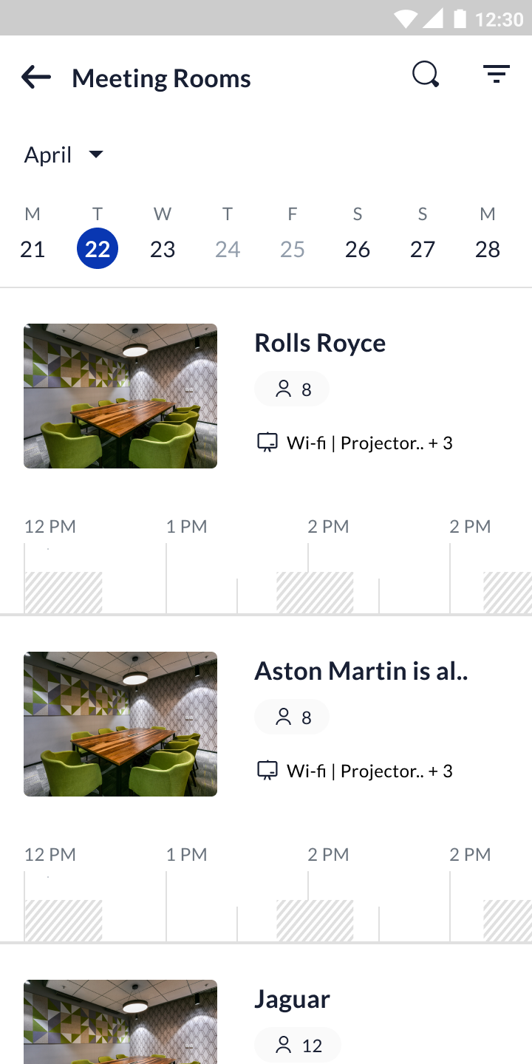
- In case of room unavailable for that particular start time, but available during the rest of the time period
  - “Start meeting” option will be grayed out
  - Book Later option will be present
- What happens when a user clicks on Start Meeting CTA from homepage -
  - A form pops up which contains the time for which the user can book the room and option to add guests
  - Time:
    - Time can be in intervals of 15 mins, 30 mins, 45 mins, 60 mins
    - The options are visible only if the room is available for that time range
    - In case the time range of 30 mins, 45 mins, etc is not available for booking, then it should be grayed out
  - Add guests
    - Organizer can add guests that they want to invite to the meeting
    - When user clicks on “Add guests”, the form expands to support multiple selection
    - User can add “n” number of guests
    - If the user adds guests which are more than the screen height, then only the guests list will scroll. The other fields remain static in place
  - The form: The user can constrict the form and expand it, that should not change the data in the form unless the user chooses to close the form
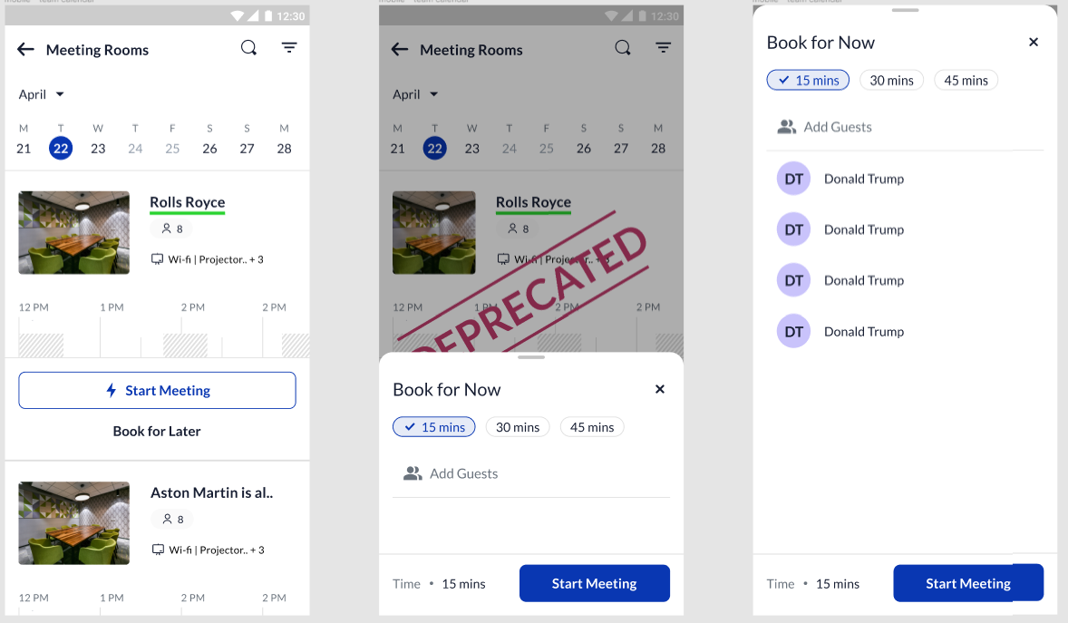

- When user clicks “Start Meeting” CTA from the form -
  - Title: The title is not visible in the “Start Meeting” form. But the value should be updated directly as “<First Name>’s meeting” while sending data to the backend. For e.g., if the user is Rishabh Ashok Maheshwari, then the title should be Rishabh’s meeting. This title should be visible only to the organizer and the guests of the meeting. Admin can view it only if they’re allowed to. Other employees view it as “Busy”
  - When a user clicks on “Start Meeting” CTA → the meeting gets created and the user is checked-in as well. User is then redirected to the app home screen where the number of meetings are reflected
  - The meeting which the user created and checked-in should show as “checked-in” next to the meeting title with a green tick
- Acceptance criteria:
  - In case user keeps the meeting form open for long and then tries to create a booking, in case room is not available, an error should be shown that “Room not available for booking”
  - The “from time” for the meeting should be the present time when the user clicks on “Start Meeting” CTA and not the time when they landed on the form

Book Later:

- Any room that is available for that day or any of the future days, should have the option to book later enabled
- Only if a room has been disabled by the admin, then “Book Later” option should be grayed out
- Once the user clicks on “Book Later”, they will land on a page which shows the calendar component

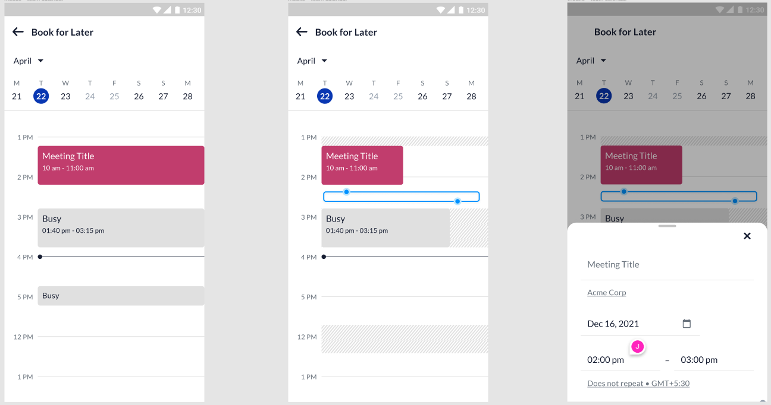

- When the user clicks on any slot that is empty, a bottom sheet appears. As and when the user changes the time from the calendar, the bottom sheet should reflect the time and change accordingly.
  - Note: When bottom sheet appears, the previous screen is NOT deprecated and continues to be visible, therefore the user can interact with both screens simultaneously
  - When user changes the selection in the screen, this changes time in the bottom sheet too
  - Users can only click a time in the future. Past time is not clickable
- The form:
  - Title: Users can enter the title of the meeting. In case user leaves in blank then automatically store it as “<user>’s meeting”
  - Room: Will be pre-selected
  - Add guests: Interface to add guests, similar to that of “Start Meeting” experience
  - Description: Optional
  - Make special request: Optional
- Once user clicks on “Save”
  - The meeting is created with the specified details
  - User is redirected to the calendar of the room where they can see their meeting for the specific day and time that they created

Calendar Component (Room Home page):

- The hatched area indicates that the room is booked and non-hatched indicates available
- The longer line indicates the hours and the shorter line indicates 30 mins
- At any point in the home screen, only 3.5 hours should be displayed
- The calendar component in home screen is scrollable, i.e., the user can scroll through the calendar to see availability of the room for the rest of the day on a selected date
- When the user scrolls through the component, only 1 hour previous to the present hour is visible and the rest of the hours in the particular day

Home page of app (Showing meetings):

- The home page of the app should show the number of meetings available for that particular day against an office booking. It shows all meetings for that particular day irrespective of the time.
- Hierarchy of the card for meeting rooms should be post that of the booking
- Based on the number of meetings, the text should say “n meetings” → where n says the number of meetings in the office (which contain room) for that particular day. Note: For a single meeting, it should say “1 meeting” and not “meetings”
- Meetings that are present in the user’s calendar, but do not have a room associated with them will not be visible in this screen
- Meetings created at any point in the day should be reflected in the home screen by updating the number of meetings
- The arrow navigates to a web view where the user can see all their meetings in a calendar and check-in into the meeting. (Check-in part is V2)

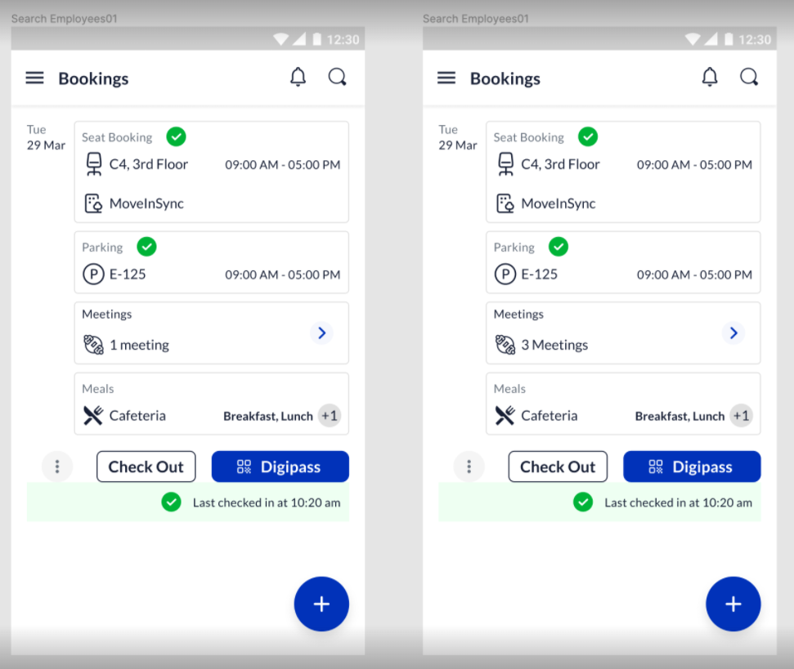

User’s calendar (Showing meetings):

- When the user clicks on the “Meeting component” in the app, it navigates to the user’s calendar view where all the meetings of the user is visible
- The calendar view shows meetings which may or may not have a room associated with it
- When the user clicks on the meeting, a scrollable bottom sheet opens up which shows the location of the meeting, scheduled time of the meeting, and an option to check-in into the meeting

Meeting room Check-In:

- As a meeting participant I should be able to CheckIn to Meeting Rooms (App) so that the meeting room is not freed up.
- Check-In into the meeting room will be through Scan QR code in Version 1.1
- If Meeting room is not checked in within stipulated time, system will release the meeting room
  - The configuration will be MEETING_ROOM_RELEASE_IF_NO_CHECKIN - 15 minutes (by default)
  - This value will be in minutes, and will be considered from meeting start time
  - This will not delete the meeting, this will only release the meeting room
- Notification/Email will be triggered to the user, “ Meeting Room <XYZ> has been removed from your meeting at 12:30 PM, as no one checked in to the meeting room. Others will be able to book it.” - to the organizer.
- Meeting room will not be released even if one person checks into the meeting room
- The Meeting room will be released early if all the employees checkout from the meeting room
- Scanning of meeting room QR code and check-in
  - When an user clicks on the check-in button, it opens the camera which scans the QR code of the room
  - System requests for GPS to be enabled which is a configurable property
    - If property enabled → GPS check is enabled, i.e., the system prompts the user to turn on GPS and doesn’t proceed in case the GPS is not turned on
    - If property disabled → GPS check is disabled, i.e., the system does not prompt the user to turn on GPS
  - Post the GPS identification, system scans and detects the valid QR code and checks the user into the room
- In case user scans the wrong QR code -
  - User is not checked-in into the room
  - User sees an error message “Oops! This isn’t the QR code of the room. Please scan the right QR”
- Once the user checks into the room, the user is redirected to the user’s calendar where a tick mark is displayed against the name of the meeting
- Note: Multiple users can check-in into the same room incase they are invited to the meeting in that room before the room is released

Calendar Component (Home page of app):

- The hatched area indicates that the room is booked and non-hatched indicates available
- The black line indicates the present time
- Only the meeting that is booked by the user should have the title visible. Other titles should be visible as “Busy” with the organizer’s name and time. The admin can see the titles
- Users should not be able to select a time in the past
- Users should be able to select a time (indicated by blue) and able to move the selection similar to that of google calendar
- In case a room is disabled, the calendar should show as completely booked and not allow users to click anywhere in the calendar
- Users should not be able to click on any other user’s meeting

Sort Available Rooms:

With the increasing number of meeting rooms, it is important to ensure scalability and performance of meeting rooms.

General:
- At a time, only 10 rooms should load, and the rest of the rooms should load later (infinite scroll experience)
- By default the rooms in the user’s profile office should load both on app and web (This experience will be enhanced when better sorting is built in Version 3)
- In version 1.1, rooms will load “Alphabetically - A to Z”
- In case the user chooses a particular sort, the sort method stays valid until the user navigates away from the meeting room UI
- In case the user applies filters, the sort method chosen stays valid until and unless the user clears it. Once cleared, it will load “Alphabetically - A to Z”

Sorting of Rooms: Rooms can be sorted in various categories

- Capacity – Version 1.1
  - Rooms can be sorted in increasing / decreasing order based on their capacity
  - In case of increasing order of capacity, UI should show “Capacity - Low to High”
  - In case of decreasing order of capacity, UI should show “Capacity - High to Low”
  - In case of rooms with similar capacity, then they should be sorted alphabetically (A to Z)

- Alphabetically – Version 1.1
  - Rooms will be sorted alphabetically in ascending / descending order based on their names
  - In case of ascending order, UI should show “Alphabetical - A to Z ”
  - In case of descending order, UI should show “Alphabetical - Z to A ”

- Distance from desk booked – Version 3
  - The user should be able to see the rooms that are closest to their desk booking
  - Users should first see the rooms closest to their desk on the same floor, in increasing order. The user should then see the rooms in other floors with rooms sorted alphabetically
  - Sorting of the floors → user sees the floor first that they have booked desk, next the lower floor (to be continued)

- Duration of availability – Version 2
  - Users see the rooms sorted in descending order with highest duration visible first
  - Might have to select start time (to be continued)

- Frequently used – Version 2
  - 3 most frequently used rooms by the user in the last 30 days
  - This is dependent on both rooms booked and used by the user. Top 3 after considering both the parameters
  - Used here refers to the rooms that the user was invited and checked-in into. Rooms that the user was invited but did not check-in into will not be considered.

- Most popular (may not be relevant) – Version 2
  - Rooms that are frequently used by all users in the floor / building / office in the last 30 days

- Amenities (may not be relevant) – Version 3

- Preferences set by the user (future)

Filter Available Rooms:

- Rooms can be filtered with the following -
  - Office:
    - By default, the profile office of the user is in selected state
    - User can only select one office at a time
  - Floor
    - By default, all the floors in the office load
    - User can select more than one floor at a time (Multi-select filter)
  - Capacity
    - By default, rooms with all capacities load
    - User can select rooms with different capacities at the same time (Multi-select filter)
  - Amenities
    - User can select one or more amenities while applying filter (Multi-select filter)
    - In case a user selects only amenities, without selecting the office, then all the rooms which contain that amenity in the user’s default office will be loaded
    - In case user selects a particular office and then selects the amenities, then all the rooms containing those amenities in the selected office will be loaded
- Hierarchy:
  - Profile office remains as default selected filter. All the floors, capacity and amenities present only in that office should be displayed
    - In case an office does not have room with capacity 3, then that should not be visible in the filter selection
  - If a floor is applied as the first filter, then the capacity and amenities present in that floor should be displayed
  - If capacity is applied, then all the rooms with that capacity in the profile office / selected office should be visible
  - If amenities is applied, then all the rooms with that amenities in the profile office / selected office should be visible
- The filter should honor the date selected by the user while applying the filter
- Incase the user applies the filter and then changes the date, the filter should stay valid for the date changed as well
- In case the user sorts rooms after applying the filter, the filter should remain valid for the chosen sorting method

Search Room:

- User can search a room by the name of the room
- After the user enters 3 letters, the name of the room should be visible in the list of suggested rooms which have name close to the 3 letters
- The user should be able to select the name of the meeting room from the list of suggested names. In case user searches for a room whose name does not exist in our system, then “Room not found” to be shown
- If the user chooses a room, for e.g., Aston Martin, then only that room should be displayed on the screen. All other rooms in the list should not be displayed
- In case the room is not available for booking for that particular day, then the same should be visible but in grayed out state
- Users should be able to navigate to a date, and then search for a room. The search should honor the date selected and not override it. Similarly users should be able to search a room and then change dates. Date navigation should not override the searched room

Date Component:

- Date component allows to navigate between date and months
- When user first arrives on the room’s calendar, today’s date and month should be visible
- In case the user is on 30th of April, then the month should be April itself. Only once user changes their selected date to 1st May, the month should change to May
- User can navigate to 1 day in the past, but not beyond that
- User can navigate to any day in the future

Analytics:

Sl No | Event | Action | Description
1 | Book room on Fab | On click | Number of users navigating to the meeting room page on app
2 | Start Meeting CTA from app homepage | On click | Number of users clicking on “Start Meeting” to navigate to the form to make a booking
3 | Start Meeting CTA on booking form | On click | Number of user clicking on “Start Meeting” which results in a booking
4 | Book for Later CTA | On click | Number of users clicking on this CTA to navigate to the form to make a booking for later
5 | Confirm CTA in book later form | On click | Number of users clicking on this CTA which results in a booking
6 | Check-In | On click | Number of users clicking on “Check-in” CTA to check-in into the meeting room
7 |  | On click
8 |  | On click
9
 |  | On click
 |  | On click

Configurations:

- showMeetingRoomOnApp
  - Enabled → enables the meeting room feature on the app
  - Disabled → disables the meeting room feature on the app
  - This includes enabling fab button and meeting rooms on hamburger menu

- showQRScannerMeetingCheckIn
  - Enabled → opens the camera to scan QR code and check-in into the meeting
  - Disabled → checks-in into the meeting directly without scanning

